**Mission 8:**

**Remix**

**Student Workbook**



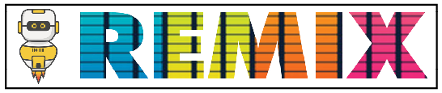

**Make a list and then get random!**

This assignment will let you be creative and come up with your own program for the   
CodeX to run.

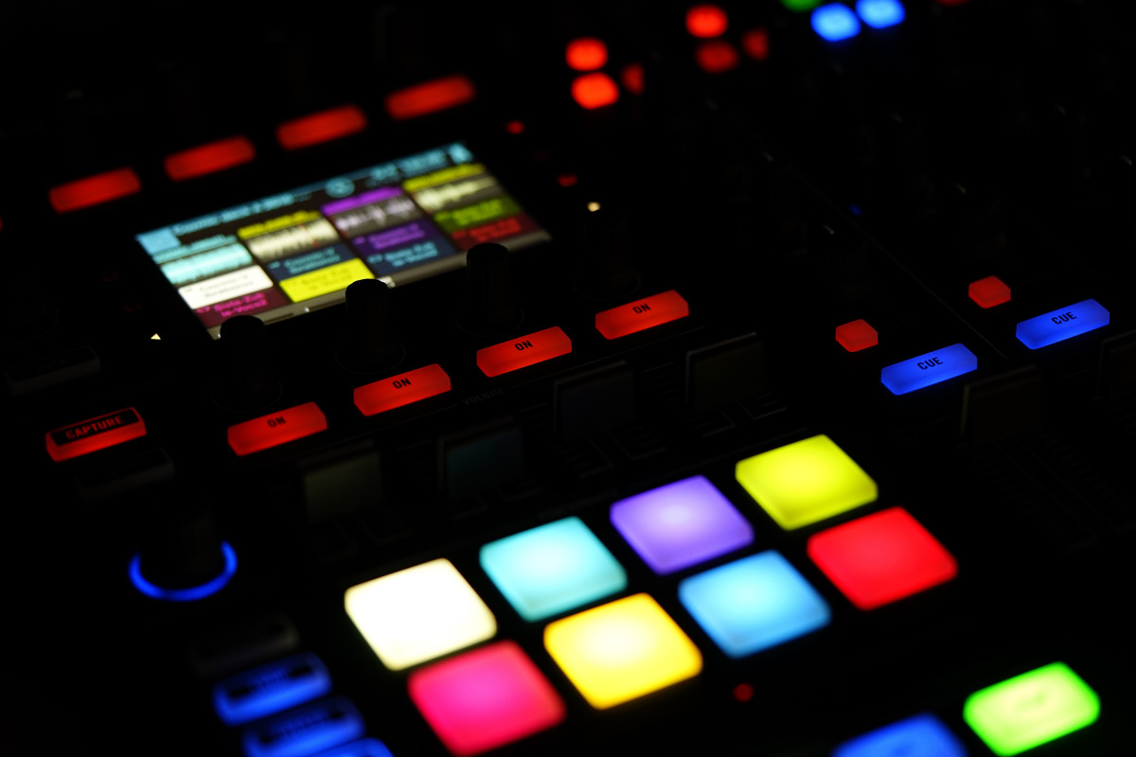

Go to the Mission 8 Remix Log and fill out the Pre-Remix preparation.





**Time for a project remix**

A remix can be:

* A new program created by adding new code to a program you already created
* You can combine parts of two or more programs in a remix
* Use a similar idea in a different way

**Creating a remix will let you:**

* Master the skills and concepts practiced in the mission
* Be creative
* Remember code from earlier programs and missions
* Work with your peers
* Design an original program and write the code all on your own

**Step #1: Review the mission**

* Review your programs from Mission 3 through 8
  + What do the programs do?
  + What skills were used or concepts learned?

**DO THIS:**

* Open your project from Mission 8 -   
  Answer Bot
* Review what the program does
* Review the programming concepts and skills you learned
* 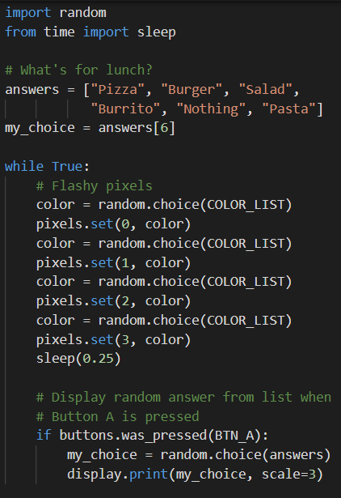Fill out the information in the remix log

**Step #2: Brainstorm ideas**

* Read through remix suggestions.
  + Six ideas are on the next pages. You can use any of these ideas or come up with your own.
  + You can combine any parts of the suggestions into your own mild, medium, spicy or extra spicy remix.
* Use your creativity to come up with your own idea for a project.
* Decide with your partner what project you will do.

  
**Mild Remix #1A**

Create a list of colors. When a button is pressed, pick a random color and turn on all four pixels. Or use two buttons - Button A for pixels 0 & 1, and Button B for pixels 2 & 3

[Video of Remix #1A (all four)](https://youtu.be/5ZT2Yy0aHFY) / [Video of Remix #1A (two buttons)](https://youtu.be/GAgjkdjI1xk)



**Mild Remix #1B**

Create a list of images and/or colors. When a button is pressed, pick a random image/color to display. Also program a button to break out of the loop and end the program.

[Video of Remix #1B](https://youtu.be/ytcHNzGy18Y)



**Medium Remix #1C**

Create a list of sounds. When a button is pressed, pick a random sound to play. Also program a button to break out of the loop and end the program.

[Video of Remix #1C](https://youtu.be/jBmB3cr4q6k)



**Medium Remix #2**

Create two lists. The items can be colors, text, images or sound. The lists do not need to be similar items or the same size. Use BTN_A to select one of the lists and BTN_B to select the other list and display a random item from the list when pressed. Program a button to break out of the loop and end the program. Include instructions and a “wait” button.

[Video of Remix #2](https://youtu.be/4xMbcOJAb3g) / [Video of Remix #2 with JPG images](https://youtu.be/VM1rSgJ7hXM)



**Spicy #3A**

Create 2 different lists, selected with BTN_A and BTN_B buttons. Program BTN_L to scroll backwards, BTN_R to scroll forwards, and BTN_U to select a random item from the chosen list. Include an intro, wait button and exit button.

[Video of Remix #3A](https://youtu.be/ZQqelFUQOvg) / [Video of Remix #3A (with JPG images)](https://youtu.be/ZWuG6ctKgi4)



**Spicy Remix #3B**

Create a dice roller, showing the number of a 6-sided die. Change the scale of the text so the number is large. Show a message, like “rolling” before displaying the number.

[Video of Remix #3B](https://youtu.be/1vseZ4jgLrM) / [Another version of Remix #3B](https://youtu.be/ZXi_JCFIAZg)

.

**Step #2: Brainstorm ideas  
DO THIS:**

* Decide with your partner what project you will do
* 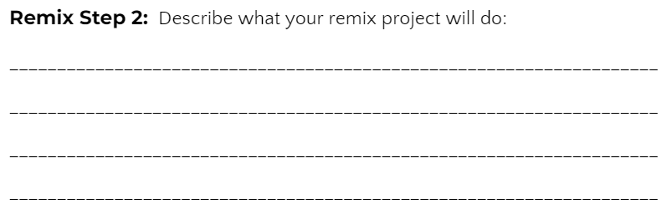Fill out the information in the Mission 8 Remix Log for **Step #2**

**Step #3: Make a plan**

Now that you have an idea for your remix, you need a plan.

* What variables will you need?
* What lists will you use, and what will be their items?
* What buttons will you program, and what will each button do?



**DO THIS:**

* Fill out the information in the Mission 8 Remix Log for **Step #3**

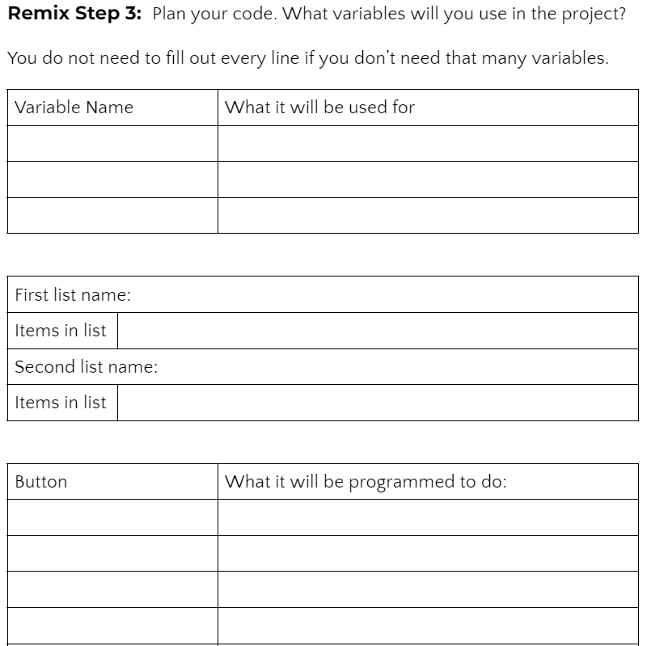

**Step #4: Code your project**

* **IMPORTANT:** In CodeSpace, go to the sandbox: 
* You can leave any program open, including **Answer Bot**, and use it as a guide

**DO THIS:**

* Start with a new file and give it a descriptive   
   name (**Remix8**)
* Import your modules
* Create your lists
* Define your variables
* Write your code, testing frequently

**Reminders!**

* Don’t try to write all the code at one time
* Mistakes happen, so find them early
* Type just a few lines of code and then run the program
* If there is an error, fix it before continuing
* Use the debugger and your other programs for help

**Step #5: Documentation**

You should always make your code readable and easy to follow.l

**DO THIS:**

* + - * Add blank lines where needed to divide sections of code
      * Add a comment at the top with your name and the name of the program
      * Add a few more comments to sections of your code that explain what they do

**Step #5: Get feedback**

Getting feedback and reflecting on your code can help you make the program even better.

**DO THIS:**

* Show your code to another student
* Have him/her fill out the feedback form on your   
  Mission 8 Remix Log
* Give yourself some feedback
* Is there something you want to change or   
  improve or add?
* Fill out the feedback form on your Mission 8   
  Remix Log

**Modify your code to make your project even better**

**Congratulations!**

Now you have your own remix!   
Great job! Share your project with   
your friends.

By completing this remix you have:

* learned more about programming
* used skills and concepts from the missions
* been thinking!
* and problem solving
* and much more!
* 

**DO THIS:**

* Run at least three projects from other   
  students
* Complete the Mission 8 Remix Log
* Don’t forget to clear your CodeX by running your **Clear** program